<Student Name>

<Titel>
<Untertitel>

iimt
Chair of Management in ICT, international institute of management in technology, University of Fribourg
Reviewers: Prof Dr Stephanie Teufel
<Assistent>

submitted by
<Student>
<Student-ID>

Acknowledgement
This document is a ‘ready-to-use’-template for academic theses. The iimt recommends inserting your text directly in this document. The thesis is formatted in accordance to the described formatting principles in this template. This document provides information regarding following points:
• Correct caption of figures/tables/equations
• Clarifies the insertion of references and literature-management software, and
• Describes general points on a thesis’ structure
Inform the research assistant timely if you have further questions, remarks, or corrections.

Management Summary
Text, Text, Text

Table of Contents

Acknowledgement I
Management Summary II
Table of Contents III
List of Figures IV
List of Tables V
Abbreviations VI
1 Introduction 1
2 Formatting 2
2.1 Figures, Tables, Equations 2
2.2 Quotes and References 4
2.2.1 Structure 4
2.2.2 Structure, Part II 5
3 Name of the Chapter 6
4 Name of the Chapter 7
5 Name of the Chapter 8
6 Conclusion 9
Bibliography VIII
Appendix 1: xxx IX
Appendix 2: Declaration that the project is the candidate`s own work X

Delete this text: Note that the thesis includes roman numbers for the general parts in the beginning as well as for the ending.

List of Figures

Figurer 1: Example ‘Figure’ 2
Figure 2: Example ‘Figure with Author’ 3
Figure 3: ideas@iimt-Logo 7

List of Tables

Table 1: Example 'Table' 3
Table 2: Example 'Table with Source' 4

Abbreviations
API | Application Programming Interfaces
ICT | Information and Communications Technology
SVO | Social Value Orientation

Introduction
Lorem ipsum dolor sit amet, consetetur sadipscing elitr, sed diam nonumy eirmod tempor invidunt ut labore et dolore magna aliquyam erat, sed diam voluptua. At vero eos et accusam et justo duo dolores et ea rebum

Formatting
Lorem ipsum dolor sit amet, consetetur sadipscing elitr, sed diam nonumy eirmod tempor invidunt ut labore et dolore magna aliquyam erat, sed diam voluptua. At vero eos et accusam et justo duo dolores et ea rebum. Stet clita kasd gubergren, no sea takimata sanctus est Lorem ipsum dolor sit amet. Lorem ipsum dolor sit amet, consetetur sadipscing elitr, sed diam nonumy eirmod tempor invidunt ut labore et dolore magna aliquyam erat, sed diam voluptua. Application Programming Interfaces (API) vero eos et accusam et justo duo dolores et ea rebum. Stet clita kasd gubergren, no sea takimata sanctus est Lorem ipsum dolor sit amet: Social Value Orientation (SVO)

Figures, Tables, Equations
Figures/Tables/Equations must be numbered and labelled consecutively in the text. For tables, the caption is above, for figures and mathematical formulas below (see examples in this chapter).
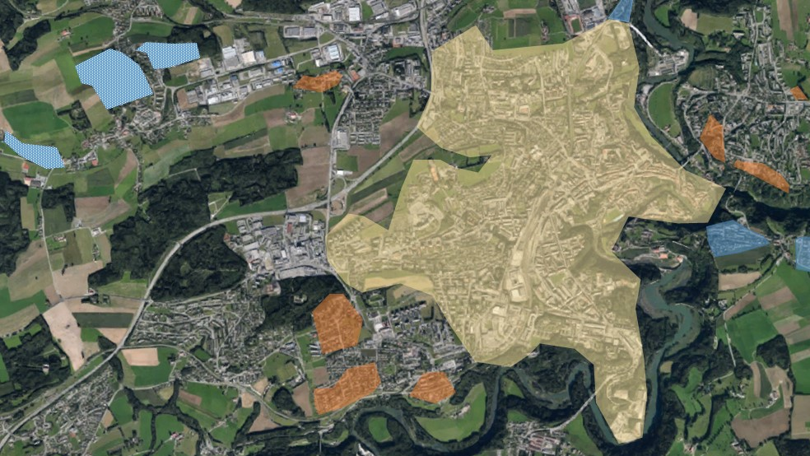
.
Figurer 1: Example ‘Figure’
Figures can be put in transparent tables in order to simplify their insertion into Word. The caption of figures/tables/equations have to be formatted as ‘Caption’ and not as ‘Text’ (like this continuous text). Figures and Tables which are not originated by the author need to be denoted as such and formatted as ‘Source’ (see also: Figure 2).
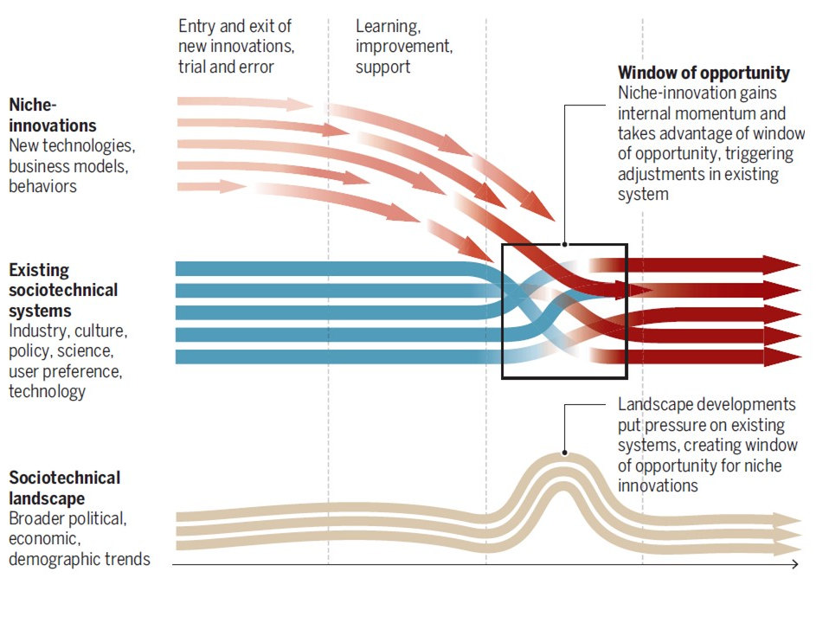
Figure 2: Example ‘Figure with Author’
Source: Geels et al. 2017, p.1244
Tables need to be designed, if possible, in a uniform manner. The titles within a table can be delimited from the table’s content. In general, font size of for tables (font size 10 for content, font size 11 for titles) should be smaller than in the text (font size 12).
Either tables (including their caption) that range over at least two pages should repeat their heading on the different pages, or should use the page break option (e.g. page break before Table 2).
Table 1: Example 'Table'
Criteria | Sample ‘A’ | Sample ‘B’
Sample Size | 100 Units | 95 Units
Locality | ‘Pérolles’ | ‘Jura’
Share of pensioners | 16.00% | 11.25%

If figures/tables/formulas are reproduced in a modified form from a source, this must be mentioned (Table 2).

Table 2: Example 'Table with Source'
Source: adapted from Hertig 2019.
Criteria | Sample ‘1’ | Sample ‘2’
Sample Size | 321 Units | 34 Units
Locality | ‘Fenettaz’ | ‘Kleinschönberg’
Share of pensioners | 16.00% | 11.25%
Share of association members | 32.18% | 12%
Share of Children (< 18 years) | 25.87% | 14.19%

Equations need to be inserted with the ‘Word’-paste option. Equations need to be inserted separately from the text:
$$SVO°=\arctan{(\frac{A_{o}-50}{A_{s}-50}})$$
Equation 1: Example 'mathematical equations'
If less than three figures/tables/equations/abbreviations are presented in the thesis, no list of such is needed.

Quotes and References
Quotes and references need to be handled according to the ‘Harvard’- or ‘APA’-reference guidelines. Information regarding these guidelines can be found on academic websites, as well as in different books in the University library.
The insertion of references cannot be done manually. Either use the tools provided by ‘Word’, or use ‘Citavi’ and ‘Zotero’. Both literature-management software are free of charge for students at the University of Fribourg. If you use one of them, inform your assistant.

Structure
The structure of your thesis allows only a 3-ary structure. Theses with 4-ary structures are not accepted, e.g. 2.2.1.1. If necessary, you can use ‘fake-headers’ to structure your chapters (see fake-headers 1-3).

Fake-Header 1
Lorem ipsum dolor sit amet, consetetur sadipscing elitr, sed diam nonumy eirmod tempor invidunt ut labore et dolore magna aliquyam erat, sed diam voluptua. At vero eos et accusam et justo duo dolores et ea rebum
Fake-Header 2
Lorem ipsum dolor sit amet, consetetur sadipscing elitr, sed diam nonumy eirmod tempor invidunt ut labore et dolore magna aliquyam erat, sed diam voluptua. At vero eos et accusam et justo duo dolores et ea rebum
Fake-Header 3
Lorem ipsum dolor sit amet, consetetur sadipscing elitr, sed diam nonumy eirmod tempor invidunt ut labore et dolore magna aliquyam erat, sed diam voluptua. At vero eos et accusam et justo duo dolores et ea rebum

Structure, Part II
Another subchapter must follow each subchapter: on ‘subchapter 1.1’ must follow ‘subchapter 1.2’. Therefore, a single subchapter cannot structure a single chapter. A ‘chapter 1’-‘subchapter 1.1’-‘chapter 2’-structure is not allowed.
Finally, at the end of the chapter, use a page break to start the new chapter on a new page (e.g. see chapter 3). However, this does not apply to subchapters

Name of the Chapter

Name of the Chapter
Lorem ipsum dolor sit amet, consetetur sadipscing elitr, sed diam nonumy eirmod tempor invidunt ut labore et dolore magna aliquyam erat, sed diam voluptua. At vero eos et accusam et justo duo dolores et ea rebum
Figure 3: ideas@iimt-Logo
Lorem ipsum dolor sit amet, consetetur sadipscing elitr, sed diam nonumy eirmod tempor invidunt ut labore et dolore magna aliquyam erat, sed diam voluptua. At vero eos et accusam et justo duo dolores et ea rebum

Name of the Chapter

Conclusion

Bibliography

Appendix 1: xxx

Appendix 2: Declaration that the project is the candidate`s own work
I hereby declare that I wrote this thesis on my own and followed the principles of scientific integrity.
I acknowledge that otherwise the department has, according to a decision of the Faculty Council of November 11th, 2004, the right to withdraw the title that I was conferred based on this thesis.
I confirm that this work or parts thereof have not been submitted in this form elsewhere for an examination, according to a decision of the Faculty Council of November 18th, 2013.

……………………………..……,...................................... 20..........

...........................................

(Signature)

